**Topics: Descriptive Statistics and Probability**

1. Look at the data given below. Plot the data, find the outliers and find out $μ, σ, σ^{2}$

|  |  |
| --- | --- |
| **Name of company** | **Measure X** |
| Allied Signal | 24.23% |
| Bankers Trust | 25.53% |
| General Mills | 25.41% |
| ITT Industries | 24.14% |
| J.P.Morgan & Co. | 29.62% |
| Lehman Brothers | 28.25% |
| Marriott | 25.81% |
| MCI | 24.39% |
| Merrill Lynch | 40.26% |
| Microsoft | 32.95% |
| Morgan Stanley | 91.36% |
| Sun Microsystems | 25.99% |
| Travelers | 39.42% |
| US Airways | 26.71% |
| Warner-Lambert | 35.00% |
|  |  |
|  |  |

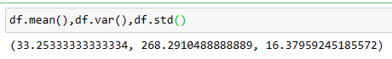

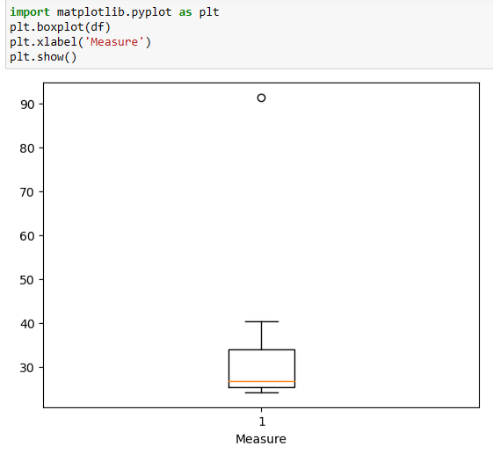

**Outliers :** (Morgan Stanley,91.36%)



Answer the following three questions based on the box-plot above.

1. What is inter-quartile range of this dataset? (please approximate the numbers) In one line, explain what this value implies.

**ANSWER :**  IQR=12-5=7 ,

This respresents the range which contains 50% of the data points

1. What can we say about the skewness of this dataset?

**ANSWER :** The dataset is right skewed

1. If it was found that the data point with the value 25 is actually 2.5, how would the new box-plot be affected?

**ANSWER :** 2.5 is not considered as outlier. The boxplot will start from 0 and ends at 20

in representation.



Answer the following three questions based on the histogram above.

1. Where would the mode of this dataset lie?

**ANSWER :**  Mode of the datasets lies between 4 & 8

1. Comment on the skewness of the dataset.

**ANSWER :**  Datasets is right skewed

1. Suppose that the above histogram and the box-plot in question 2 are plotted for the same dataset. Explain how these graphs complement each other in providing information about any dataset.

**ANSWER :**  mode in histogram and median in boxplot

Histogram provides the frequency distribution so we can see how many times each data points is occurring however boxplot provides the quantile distribution that is the 50% of the data lies between 5 and 12.

Boxplot provides whisker length to identify outliers, no information from the histogram.

We can only guess looking at the gap that 25 may be an outlier.

1. AT&T was running commercials in 1990 aimed at luring back customers who had switched to one of the other long-distance phone service providers. One such commercial shows a businessman trying to reach Phoenix and mistakenly getting Fiji, where a half-naked native on a beach responds incomprehensibly in Polynesian. When asked about this advertisement, AT&T admitted that the portrayed incident did not actually take place but added that this was an enactment of something that “could happen.” Suppose that one in 200 long-distance telephone calls is misdirected. What is the probability that at least one in five attempted telephone calls reaches the wrong number? (Assume independence of attempts.)

**ANSWER :**

let p_x = probabiity of exactly x calls getting misdirected. = 5Cx*(p^x)*(q^(5-x))

p=probability of a call getting misdirected =1/200

q=probability of a call not getting misdirected = 199/200

probability of at least one call misdirected = p_1+p_2+p_3+p_4+p_5

= 1-p_0

= 1-5C0*(p^0)*(q^5)

= 0.0248

=2.48%

1. Returns on a certain business venture, to the nearest $1,000, are known to follow the following probability distribution

|  |  |
| --- | --- |
| x | P(x) |
| -2,000 | 0.1 |
| -1,000 | 0.1 |
| 0 | 0.2 |
| 1000 | 0.2 |
| 2000 | 0.3 |
| 3000 | 0.1 |

1. What is the most likely monetary outcome of the business venture?

**ANSWER :**  The most likely outcome is 2000

Maximum is at p(2000)=0.3

1. Is the venture likely to be successful? Explain

**ANSWER :**  P(x>0)=0.6, that implies that there is 60% chance that the venture would yield profits or greater than expected returns. P(incurring losses) is only 0.2.

So the venture is likely to be successful.

1. What is the long-term average earning of business ventures of this kind? Explain

**ANSWER :**  Weighted average = x*P(x)=800. This means the average expected earning over a long period of time would be 800(including all losses and gains over the period of time)

1. What is the good measure of the risk involved in a venture of this kind? Compute this measure

**ANSWER :**  P(loss)=P(x=-2000)+P(x=-1000)=0.2. so the risk associated with this venture is 20%